**Chapter 5.7: Creating, Viewing, and Editing Text Files**

Marko Shaffer

Information Technology, Franklin University

ITEC 200: Linux Fundamentals

Professor Kagan Ulucay

6/4/2023

Red Hat System Administration I 8.2

Chapter 2 - Lab Accessing the Command Line

**Performance Checklist:**

In this lab you will edit a text file, using the **vim** editor.

**Outcomes:**

You should be able to:

* Use Vim to perform file editing.
* Use visual mode to simplify file editing.

Log in to workstation as student using student as the password.

|  |  |  |  |
| --- | --- | --- | --- |
|  | Franklin VM: | Standard User Account: | The Student's Root Account: |
| Username | kiosk | student | root |
| Password | redhat | student | redhat |

On workstation, run the **lab edit-review start** command.

**[student@workstation ~]$ lab edit-review start**

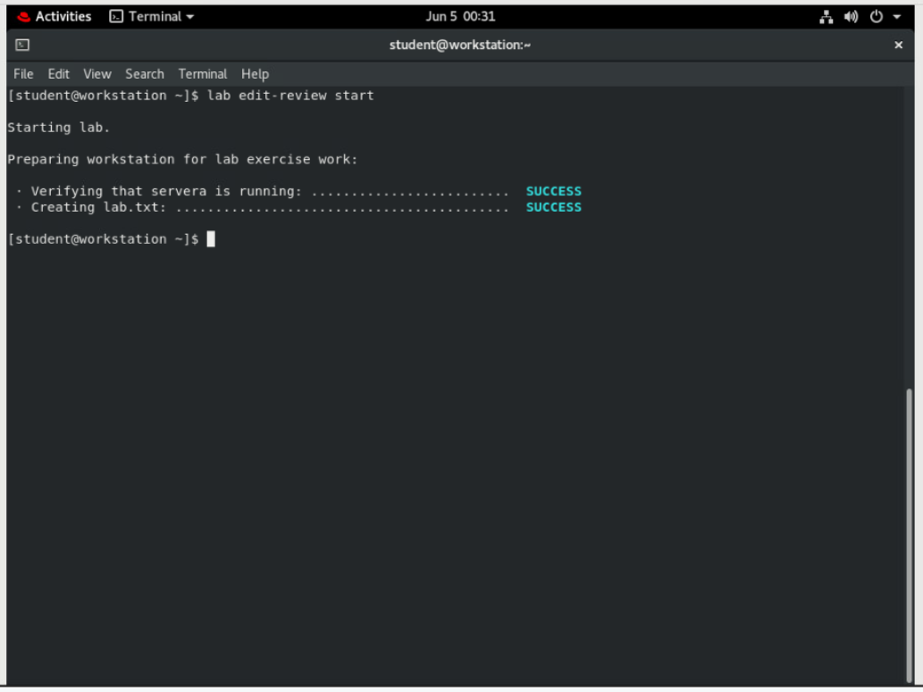

1. **Redirect a long listing of all content in the student's home directory, including hidden directories and files, into a file named editing_final_lab.txt.**

Note: The output may not exactly match the examples shown.

On workstation, from the student home directory, use the **ls -al** command to redirect a long listing of all content to a file named editing_final_lab.txt.

**[student@workstation ~]$ ls -al > editing_final_lab.txt**

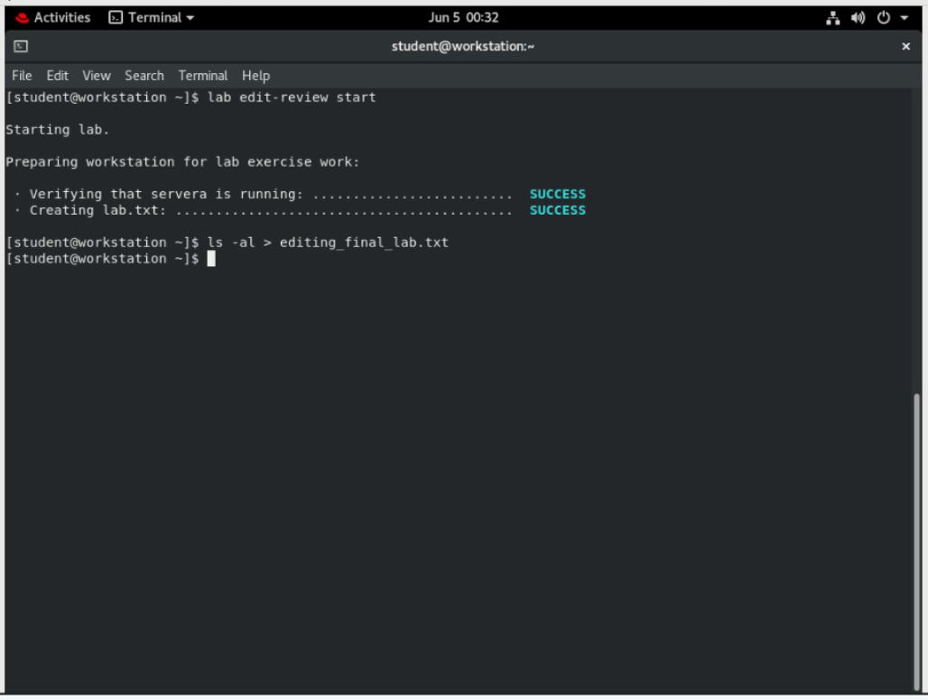

1. **Edit the file using Vim.**

**[student@workstation ~]$ vim editing_final_lab.txt**

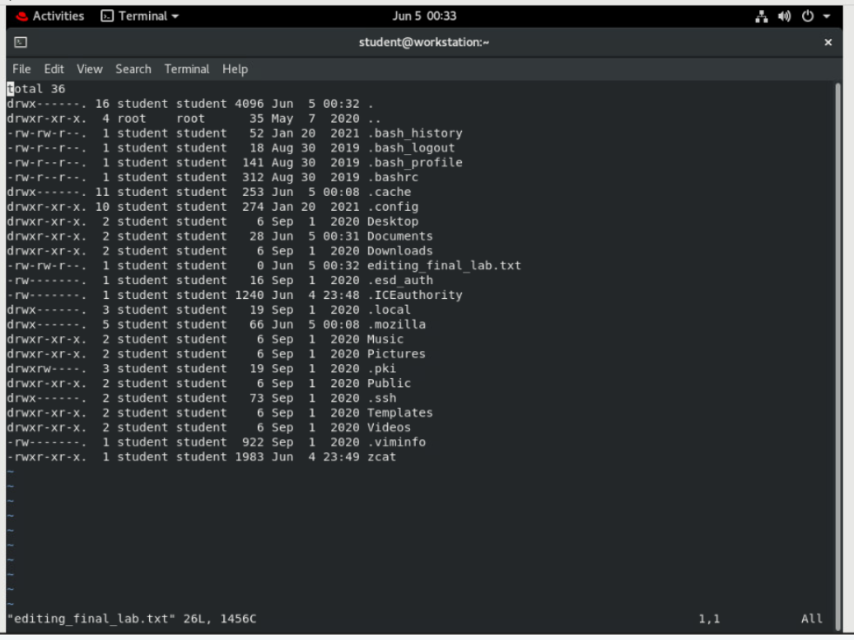

1. **Remove the first three lines. Enter line-based visual mode with uppercase V.**

|  |
| --- |
|  |

Use the arrow keys to position the cursor at the first character in the first row. Enter line-based visual mode with **Shift**+**V**. Move down using the down arrow key twice to select the first three rows. Delete the rows with **x**.

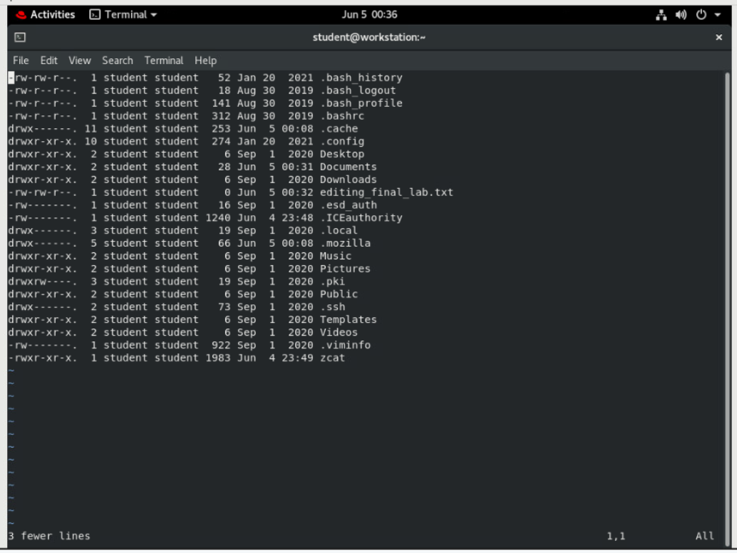

1. **Remove columns on the first line. Enter visual mode with lowercase v. Lowercase v selects characters on a single line only. The columns after -rw- should be deleted.**

|  |
| --- |
|  |

Use the arrow keys to position the cursor at the first character. Enter visual mode using lowercase **v**. Use the arrow keys to position the cursor at the last character. Delete the selection with **x**.

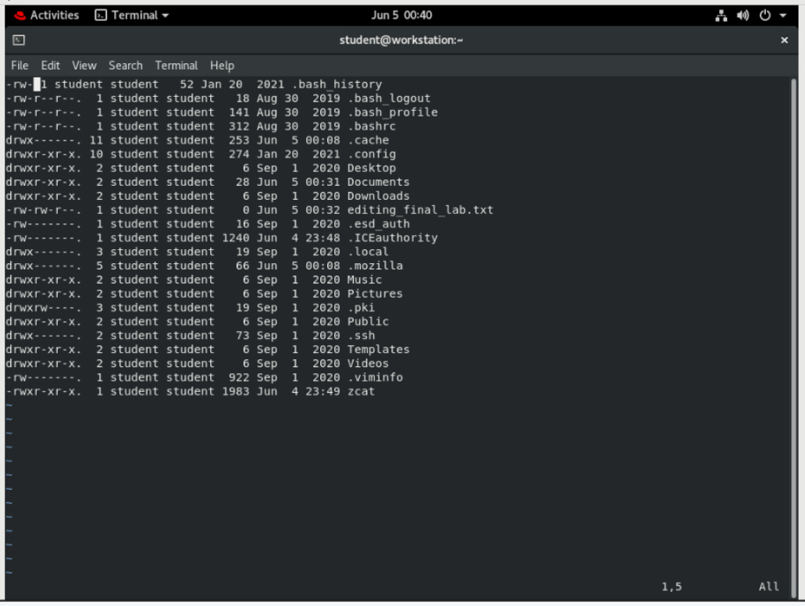

1. **Remove columns, and the subsequent dot (".") on the remaining lines. Use the visual block mode. Enter visual block with the control sequence Ctrl+V. Use this key sequence to select a block of characters on multiple lines. The columns after -rw- should be deleted.**

|  |
| --- |
|  |

Use the arrow keys to position the cursor at the first character. Enter visual mode using the control sequence **Ctrl**+**V**. Use the arrow keys to position the cursor at the last character of the column on the last line. Delete the selection with **x**.

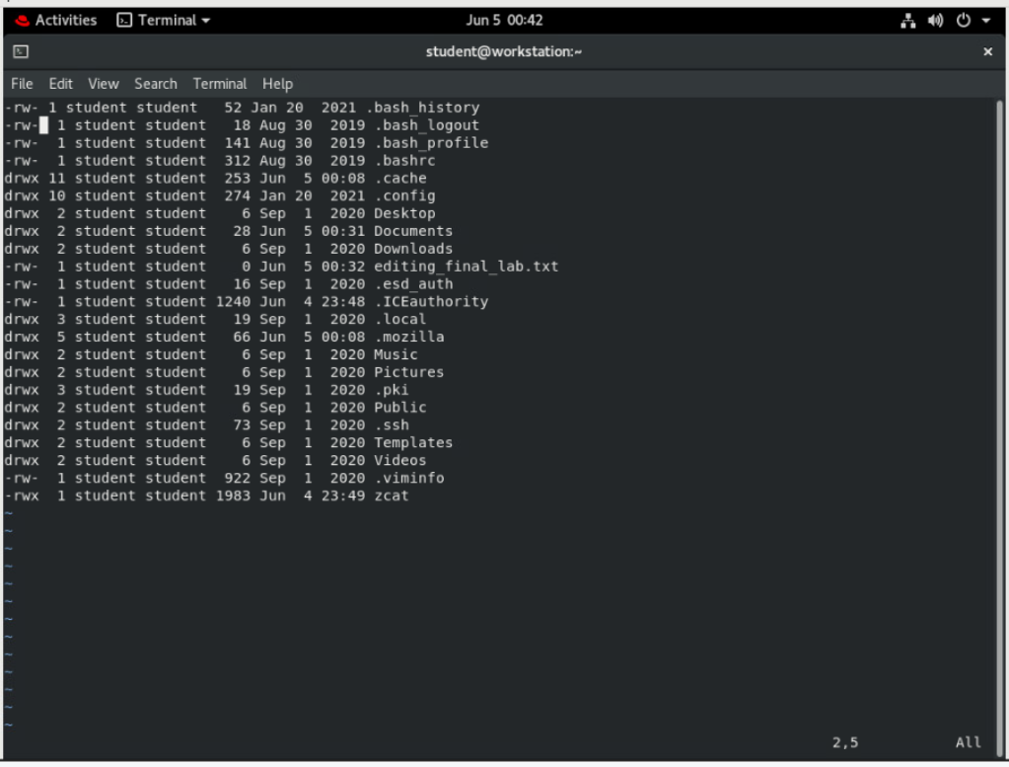

1. **Use visual block mode to remove the fourth column.**

|  |
| --- |
|  |

Use the arrow keys to position the cursor at the first character of the fourth column. Enter visual block mode using **Ctrl**+**V**. Use the arrow keys to position the cursor at the last character and row of the fourth column. Delete the selection with **x**.

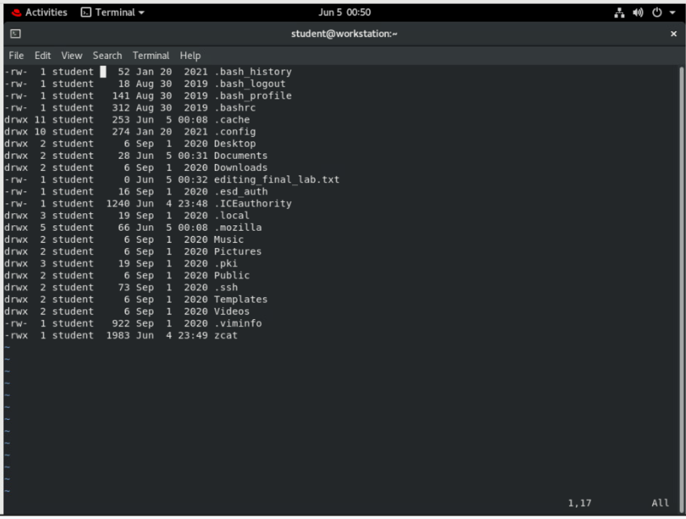

1. **Use visual block mode to remove the time column, leaving the month and day on all lines.**

|  |
| --- |
|  |

Use the arrow keys to position the cursor at the first character. Enter visual block mode using Ctrl+V. Use the arrow keys to position the cursor at the last character and row of the time column. Delete the selection with x.

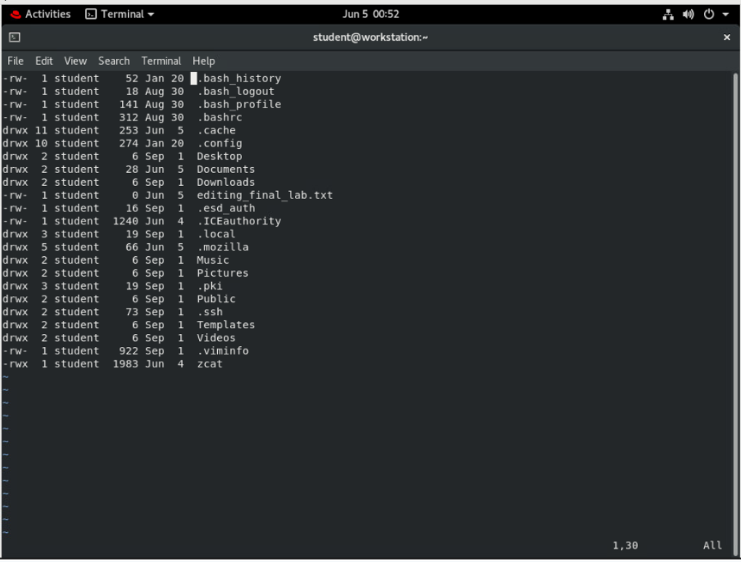

1. **Remove the Desktop and Public rows. Enter visual line mode with uppercase V.**

|  |
| --- |
|  |

Use the arrow keys to position the cursor at any character on the Desktop row. Enter visual mode with uppercase **V**. The full line is selected. Delete the selection with **x**. Repeat for the Public row.

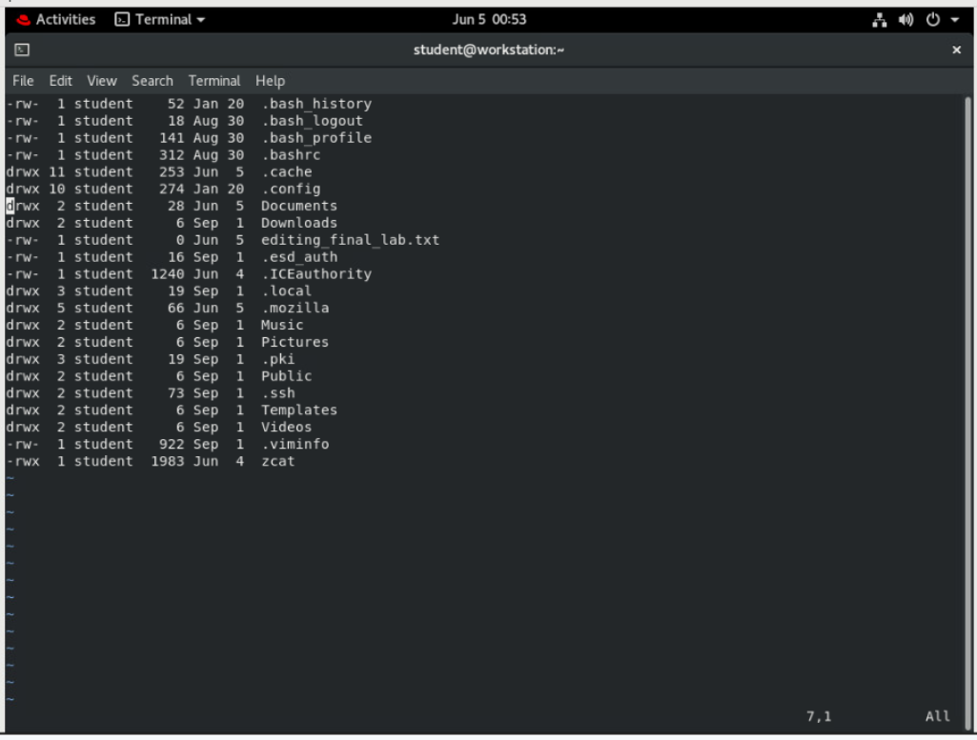

1. **Use the :wq command to save and exit the file. Make a backup, using the date (in seconds) to create a unique file name.**

|  |
| --- |
|  |

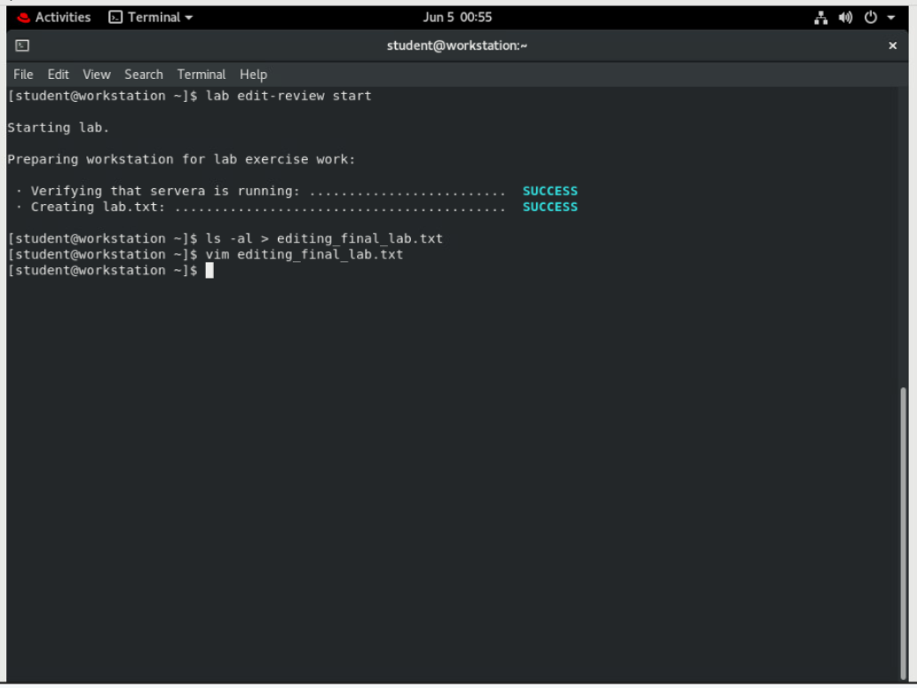

The following copy command is very long and should be entered as a single line.

**[student@workstation ~]$ cp editing_final_lab.txt**

**editing_final_lab_$(date +%s).txt**

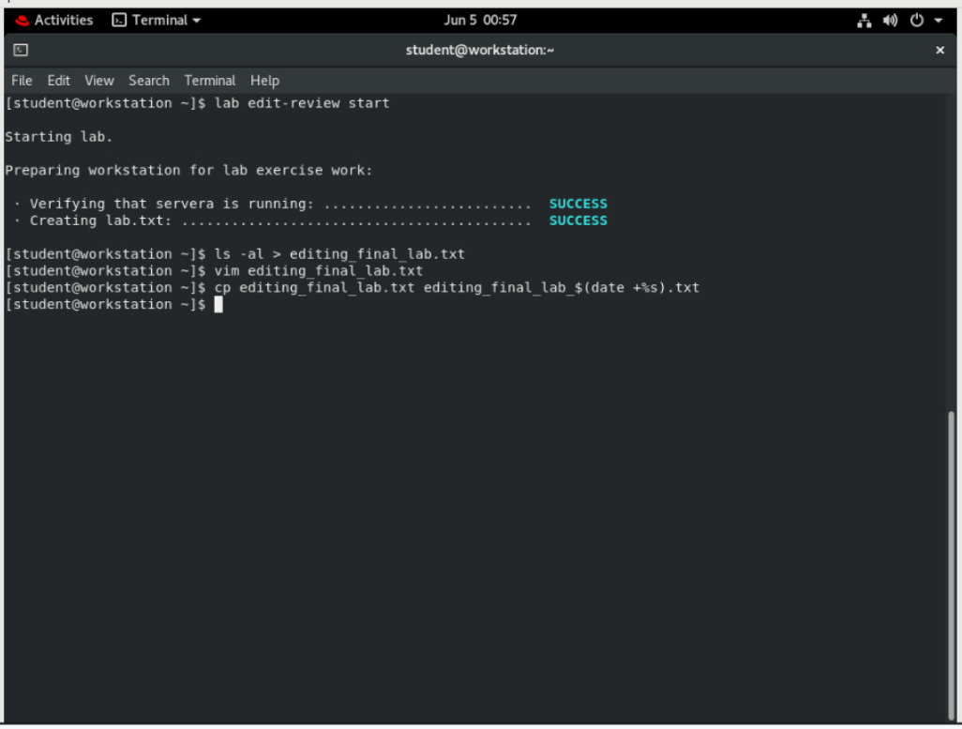

1. **Append a dashed line to the file. The dashed line should contain at least 12 dashes. The following echo command is very long and should be entered on a single line.**

**[student@workstation ~]$ echo "----------------------------------------"**

**>> editing_final_lab.txt**

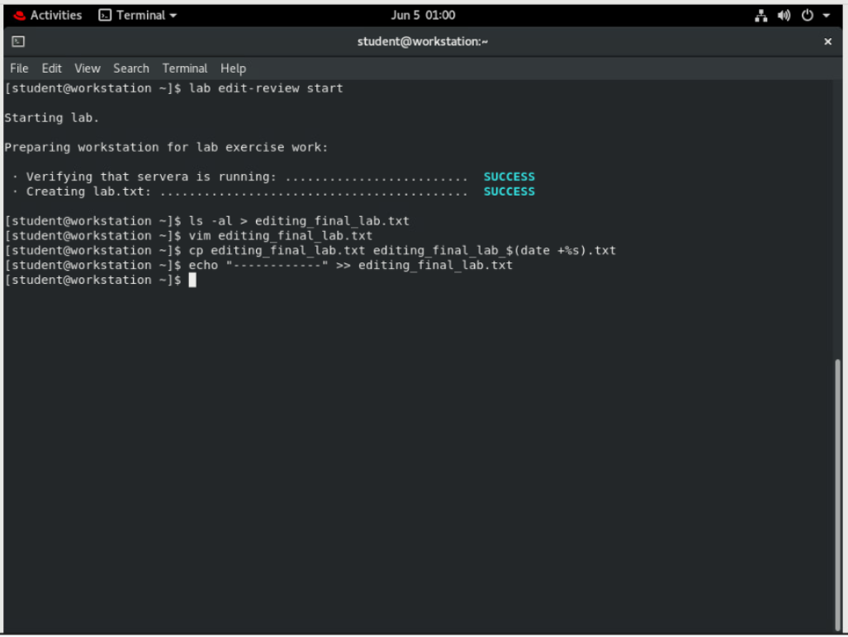

1. **Append a directory listing of the Documents directory. List the directory listing on the terminal and send it to the editing_final_lab.txt file with one command line.**

**[student@workstation ~]$ ls Documents/ | tee -a editing_final_lab.txt**

lab_review.txt

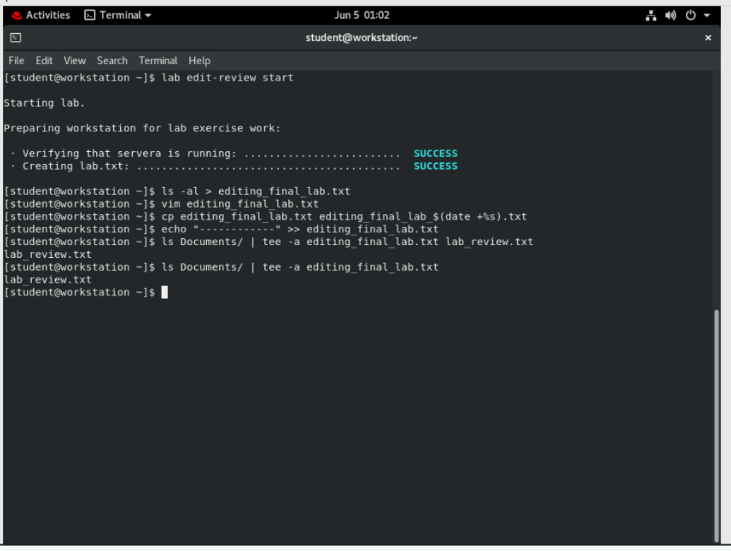

1. **Confirm that the directory listing is at the bottom of the lab file.**

**[student@workstation ~]$ cat editing_final_lab.txt**

-rw- 1 student 310 Jan 21 .bash_history

-rw- 1 student 18 Oct 12 .bash_logout

-rw- 1 student 141 Oct 12 .bash_profile

-rw- 1 student 312 Oct 12 .bashrc

drwx 8 student 201 Jan 14 .cache

drwx 10 student 203 Jan 14 .config

drwx 2 student 6 Jan 14 Documents

drwx 2 student 6 Jan 14 Downloads

-rw- 1 student 0 Jan 22 editing_final_lab.txt

-rw- 1 student 16 Jan 14 .esd_auth

-rw- 1 student 310 Jan 14 .ICEauthority

drwx 3 student 19 Jan 14 .local

drwx 2 student 6 Jan 14 Music

drwx 2 student 6 Jan 14 Pictures

drwx 3 student 19 Jan 14 .pki

drwx 2 student 73 Jan 14 .ssh

drwx 2 student 6 Jan 14 Templates

drwx 2 student 6 Jan 14 Videos

-rw- 1 student 1095 Jan 14 .viminfo

------------------------------------

lab_review.txt

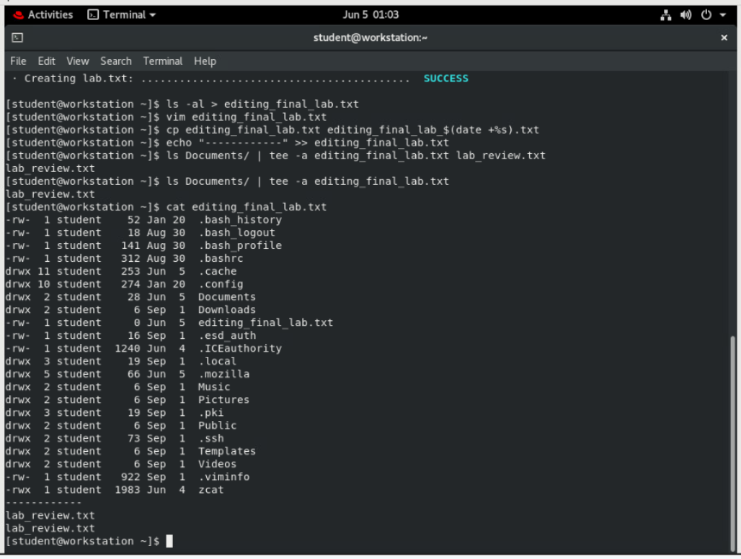

**Evaluation**

On workstation, run the **lab edit-review grade** command to confirm success of this exercise.

**[student@workstation ~]$ lab edit-review grade**

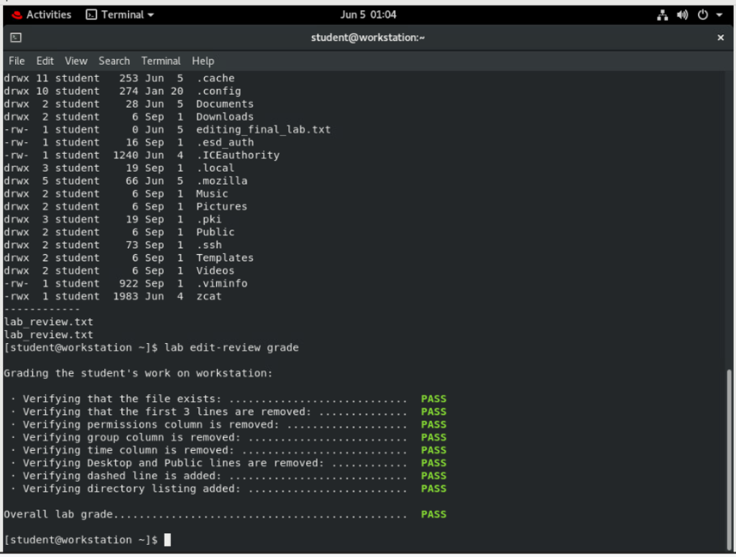

**Finish**

On workstation, run the **lab edit-review finish** script to complete this exercise.

**[student@workstation ~]$ lab edit-review finish**

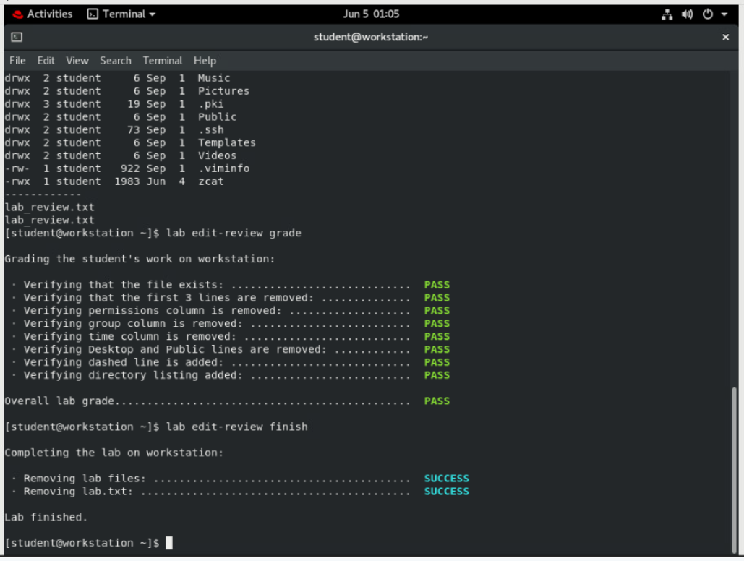

This concludes the lab.